**Department of Information Technology**

**Academic Year: 2022-23 Name of Student:**

**Semester: V Student ID:**

**Class / Branch/ Div: TE- IT B Roll No.**

**Subject: IP Lab Date of Submission:**

**Name of Instructor: YP/RS/SA**

**Experiment No.:2**

**Aim:** Write a program to create a placement registration form using HTML 5 Elements.

**Software Used:** Visual Studio Code or Sublime Editor

**Program:**

<Html>

<head>

<title>

Registration Page

</title>

<h1>Student Placement Registration Form</h1>

<style>

#d1{

background-color:gray;

}

#d2{

background-color:#80ced6;

}

#d3{

background-color:#8080f8;

}

</style>

</head>

<body bgcolor="#dfff55">

<br>

<br>

<form>

<div id="d1">

<fieldset><legend><h3>Academic Information </h3></legend><br>

<label> Last Year Percentage </label> &nbsp&nbsp&nbsp&nbsp

<input type="text" name="firstname" size="15"/> <br> <br>

<label>Any Certification: </label>

<input type="checkbox" >PCAP_Python

<input type="checkbox" >Cisco Networking

<input type="checkbox" >Redhat Linux

<input type="checkbox" >Linux essential <br><br>

<label> Project Name: </label> &nbsp&nbsp&nbsp&nbsp

<input type="text" name="lastname" size="15"/> <br> <br>

<label> Internship Completed : </label> &nbsp&nbsp&nbsp&nbsp

<select>

<option>Yes </option>

<option>No</option>

</select><br><br>

</div><br></br></br>

<field>

<div id="d2">

<fieldset><legend><h3>Personal Details</h3></legend><br>

<label> Firstname </label> &nbsp&nbsp&nbsp&nbsp

<input type="text" name="firstname" size="15"/> <br> <br>

<label> Middlename: </label>

<input type="text" name="middlename" size="15"/> <br> <br>

<label> Lastname: </label> &nbsp&nbsp&nbsp&nbsp

<input type="text" name="lastname" size="15"/> <br> <br>

<label>

Branch:

</label>

<select>

<option value="branch">Computer Engg.</option>

<option value="IT">Information Technology</option>

<option value="MECH">Mechanical Engg.</option>

<option value="CIV">Civil Engg.</option>

<option value="EXTC">EXTC</option>

</select>

<br>

<br>

<label>

Gender :

</label><br>

<input type="radio" name="gender"/> Male <br>

<input type="radio" name="gender"/> Female <br>

<input type="radio" name="gender"/> Other

<br>

<br>

<label>

Phone :

</label>

<input type="text" name="country code" value="+91" size="2"/>

<input type="text" name="phone" size="10"/> <br> <br>

Address

<br>

<textarea cols="80" rows="5" value="address">

</textarea>

<br> <br>

Email:

&nbsp&nbsp&nbsp&nbsp&nbsp<input type="email" id="email" name="email"/> <br>

<br> <br>

Password:

<input type="Password" id="pass" name="pass"> <br>

<br> <br>

Re-type password:

<input type="Password" id="repass" name="repass"> <br> <br>

</div>

<br><br>

<div id="d3">

<fieldset><legend><h3>File Upload</h3></legend><br>

Upload Resume:

<input type="file"><br></br>

Upload Marksheet:

<input type="file">

</div><br><br>

<input type="button" value="Submit"/>

</form>

</body>

</html>

**Output:**

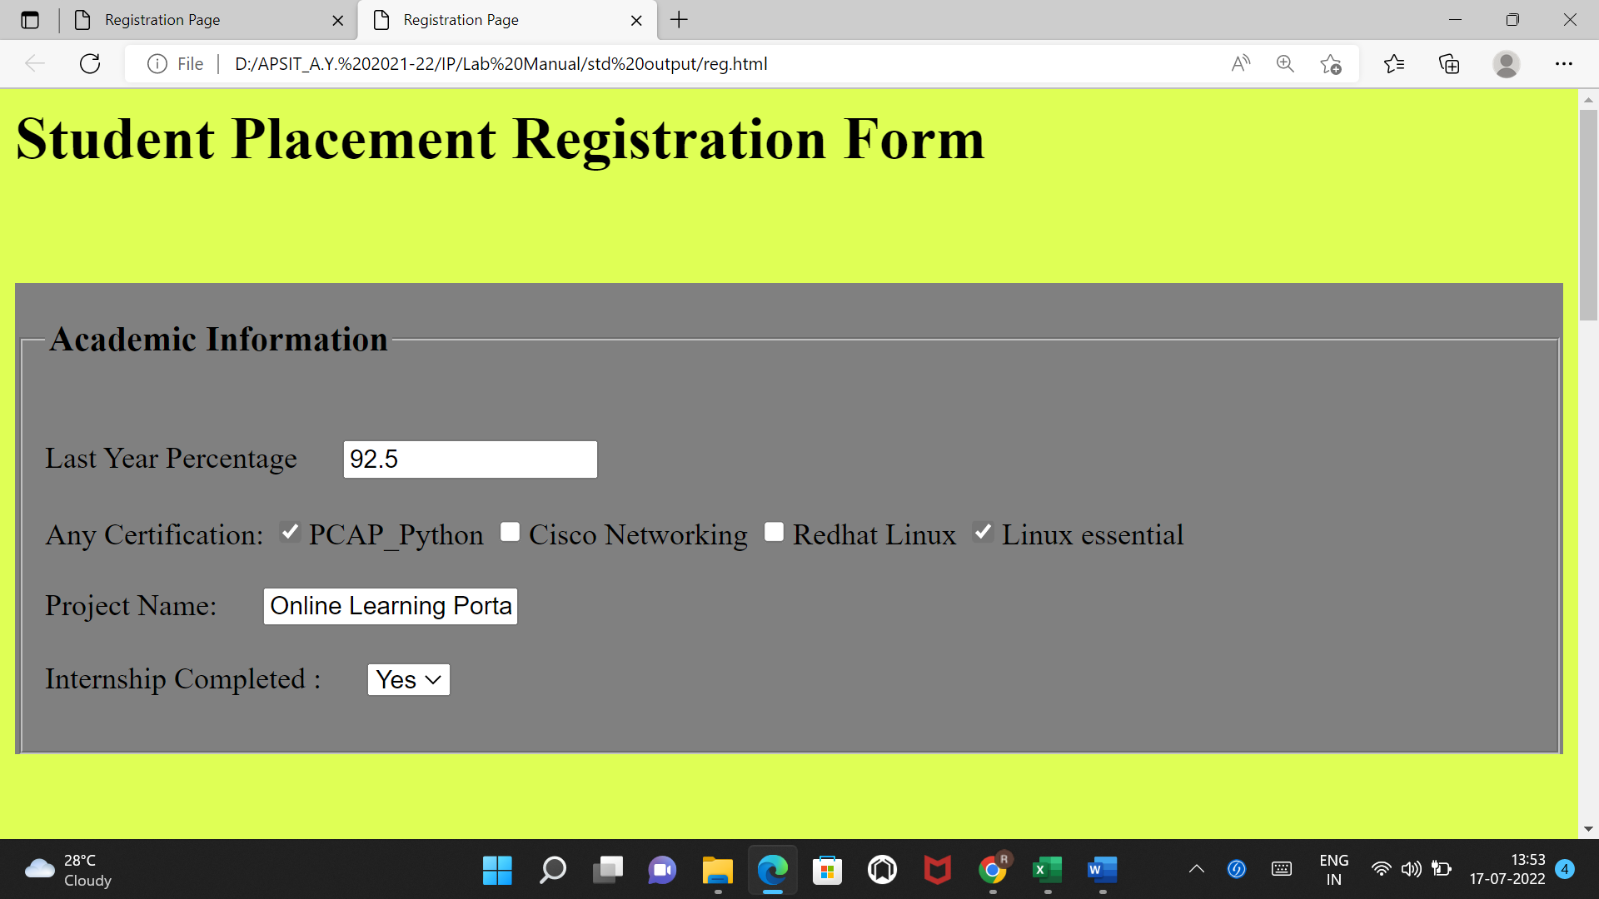

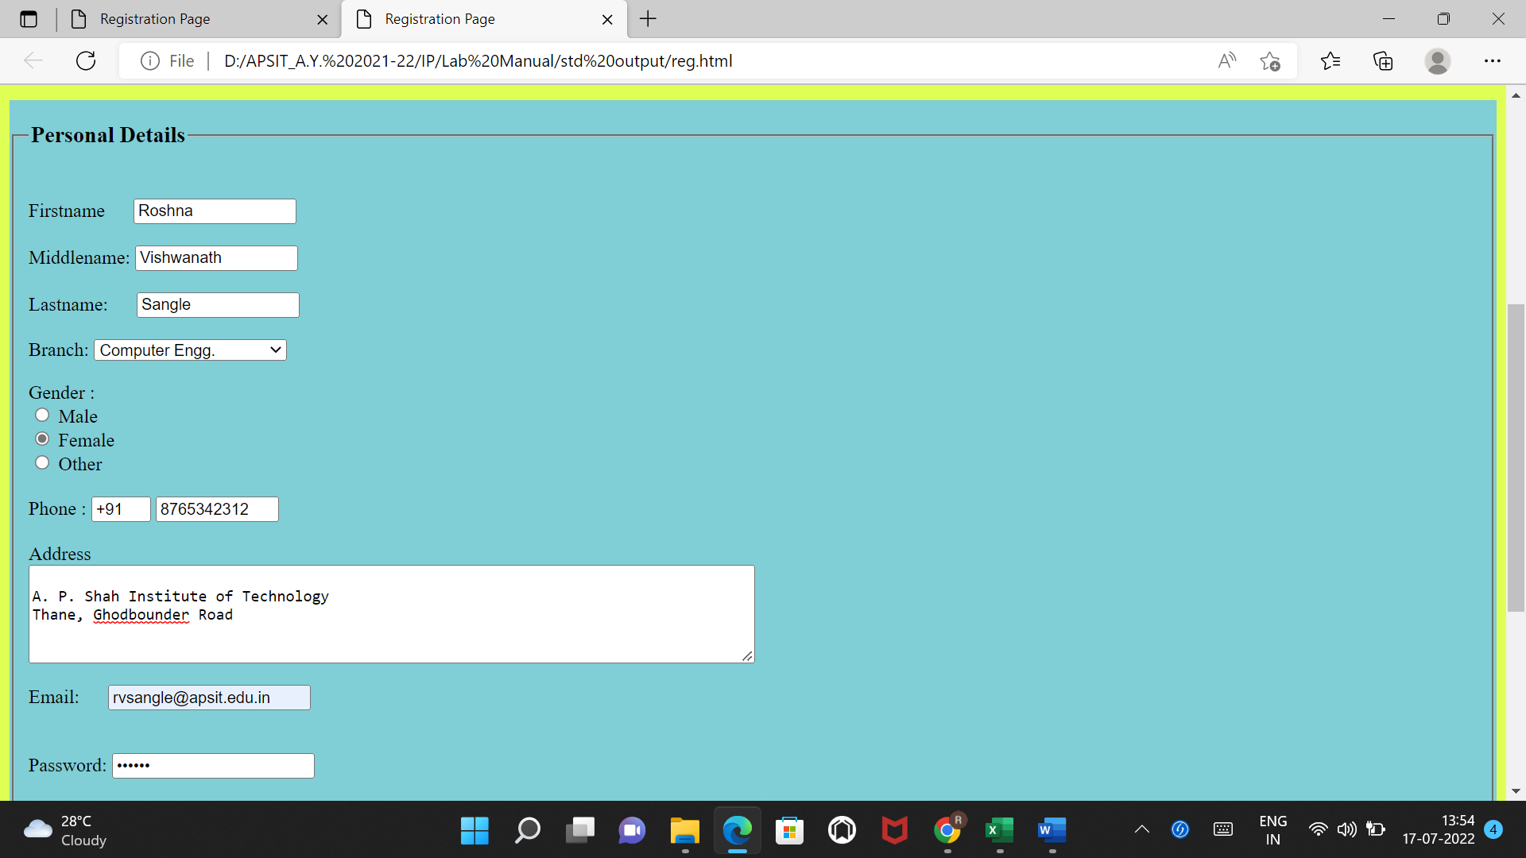

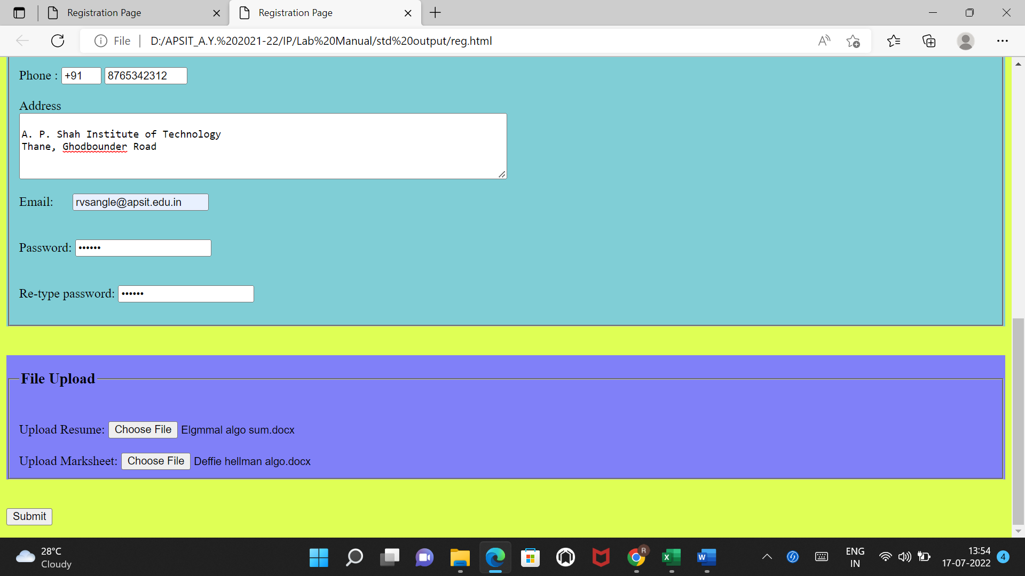

**Conclusion:** Thus we have studied FORM tag along with various data enabled fields like Textbox, Radio button, checkbox, dropdown box, Textarea ,File etc and implemented Placement Registration form using same.